EXPERIMENT 02: LOGICAL, BIT-MANIPULATION AND SHIFT OPERATIONS USING 8-BIT AND 16-BIT DATA

Objective:
- To analyze, develop and verify logical AND, OR and XOR operations.
- To analyze, develop and verify one's and two's complement operations on 8-bit and 16-bit data.
- To analyze, develop and verify bit setting, clearing, toggling, rotate and shift operations.
- To verify the output results and carry flag using the 8085 simulator.

Components Required:
8085 Simulator

Procedure:
- Switch ON the 8085-microprocessor trainer kit.
- Enter the program opcodes at the specified starting memory address using the memory examine/substitute command.
- Store the required input data in the specified memory locations.
- Execute Program A from 4100H and Program B from 4200H using the GO/EXEC command.
- Examine the memory locations assigned for the output results and flag byte.
- Record the output values and verify them against the expected hexadecimal results.
- Repeat the procedure for both programs and record the observations.

  - Analysis of Logical Operations

PROGRAM [AND,OR,XOR in 8-bit ]
LXI H, 4500H MOV A, M INX H
MOV B, M ANA B PUSH PSW STA 4502H POP H MOV A, L STA 4509H LDA 4500H ORA B
STA 4503H LDA 4500H XRA B
STA 4504H HLT

OUTPUT
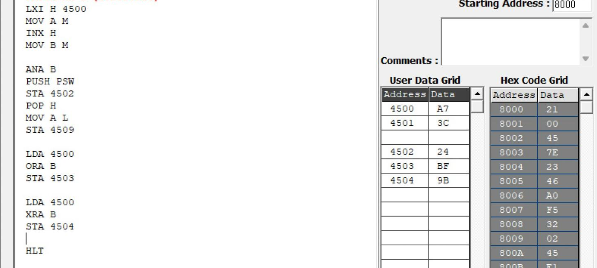

Memory | Data
4500H | A7H

4501H | 3CH
4502H | 24H
4503H | BFH
4504H | 9BH

PROGRAM [AND,OR,XOR in 16-bit ]
LDA 4500 MOV B A LDA 4502 ANA B STA 4504
LDA 4501 MOV B A LDA 4503 ANA B STA 4505
LDA 4500 MOV B A LDA 4502H ORA B STA 4506
LDA 4501
MOV B A LDA 4503 ORA B STA 4507
LDA 4500 MOV B A LDA 4502 XRA B STA 4508
LDA 4501 MOV B A LDA 4503 XRA B STA 4509 HLT

OUTPUT
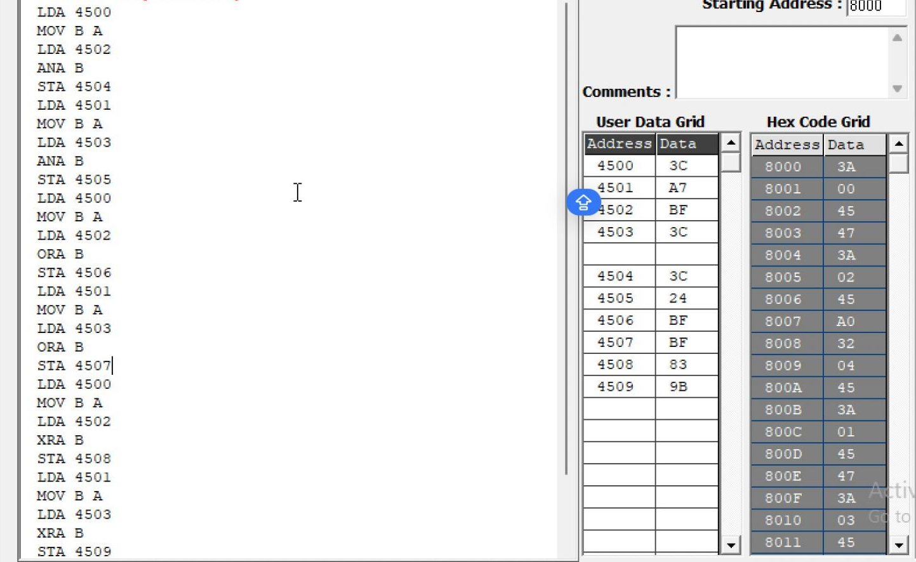

Memory | Data
4500 | 3CH
4501 | A7H
4502 | BFH
4503 | 3CH
4504 | 3CH
4505 | 24H
4506 | FFH
4507 | BFH
4508 | 83H
4509 | 9BH

  - Analysis of One's and Two's Complement

PROGRAM [16-bit]
LDA 4500H ANI 0FH STA 4505H LDA 4500H ANI F0H STA 4506H LDA 4500H CMA
STA 4507H INR A
STA 4508H
LHLD 450AH MOV A, L CMA
MOV L, A
MOV A, H CMA MOV H, A
SHLD 450CH INX H
SHLD 450EH HLT

OUTPUT
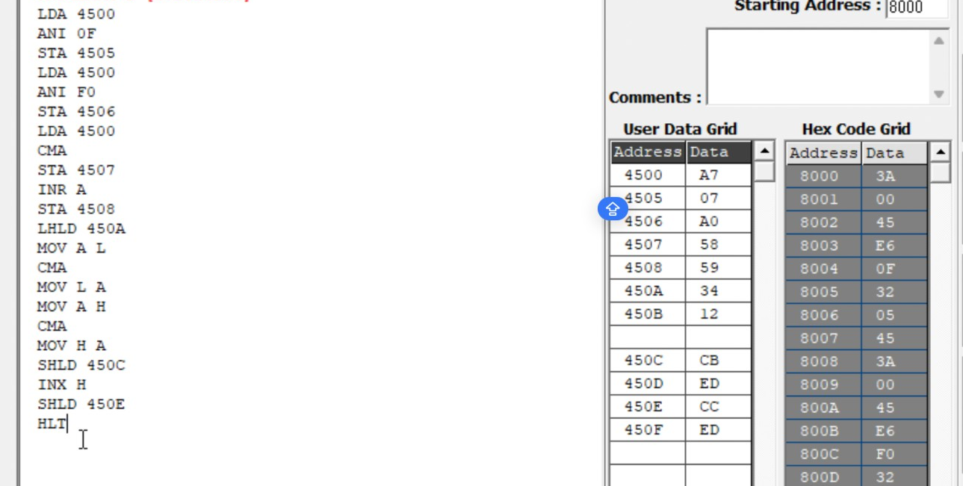
Memory | Data
4500 | A7
4505 | 07
4506 | A0
4507 | 58
4508 | 59
450A | 34
450B | 12
450C | CB
450D | ED
450E | CC
450F | ED

  - Analysis of Bit Setting, Clearing, Rotate

PROGRAM [Bit Manipulation]
LDA 4510H ORI 81H STA 4511H LDA 4510H ANI F5H STA 4512H LDA 4510H XRI 0FH STA 4513H MVI C, 00H LDA 4510H ANI 40H
JZ NEXT INR C
NEXT: MOV A, C
STA 4514H LDA 4510H RLC
STA 4515H LDA 4510H RRC
STA 4516H LDA 4510H ORA A
RAL
STA 4517H LDA 4510H ORA A
RAR
STA 4518H LDA 4510H MOV B, A RAL
MOV A, B RAR
STA 4519H LDA 4510H MVI B, 08H MVI C, 00H CNT: RLC

JNC SKIP INR C
SKIP: DCR B JNZ CNT MOV A, C STA 451AH HLT

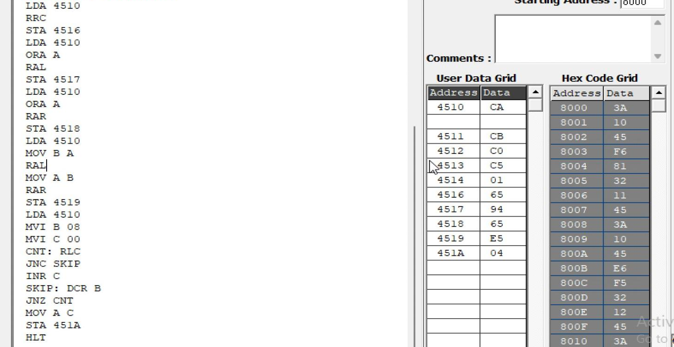
OUTPUT

Memory | Data
4510H | CAH
4511H | CBH
4512H | C0H
4513H | C5H
4514H | 01H
4515H | 95H
4516H | 65H
4517H | 94H
4518H | 65H
4519H | E5H
451AH | 04H

  - Analysis of Shift Operations

PROGRAM [16-bit Shift Left]
LHLD 4520H DAD H
SHLD 4522H HLT

OUTPUT
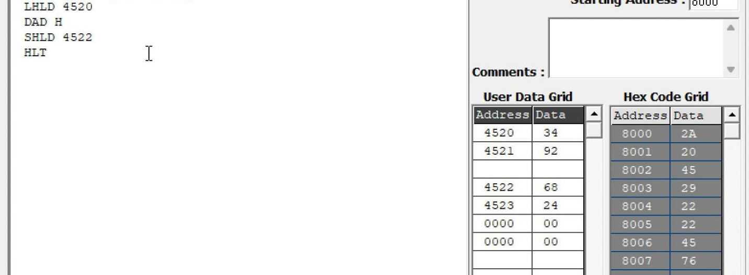

Memory | Data
4520H | 34H
4521H | 92H
4522H | 68H
4523H | 24H

Result:
Thus, the logical, bit-manipulation, complement, rotate and shift operations were performed using the 8085 simulator. The output values were examined in memory and verified against the expected hexadecimal results.

